Safety
- Put on a life jacket (PFD = personal flotation device)
Terminology
- A rope that raises a sail is called a halyard.
  - Port halyard (along the mast) is for the jib, in general.
  - Starboard halyard is for the mainsail, in general.
  - Sometimes the halyards are found at the bottom of the mast.
- A rope by which you control a sail is called a sheet.
- Grommets are holes in the sail that are reinforced by metal rings.
- Battens are short horizontal inserts in the sail that help keep its shape in the wind.
- A gunwales (pronounced “gunnel”) refers to a side of the boat.
- There are 3 types of cleats used in CBI.
  - Horn cleats (long narrow ones that we make figure ‘8’s around, e.g., for the halyards).
  - Jam cleats (tunnels through which we feed a rope through, e.g., for the cunningham)
  - Cam cleats (not used in Mercury, they are like saloon doors that open in only one direction).
- See pictures below to learn the names of the parts of a sailboat.
Storing sails
Location
- Regular mainsails are in the blue bins.
- Storm sails are in the green bins.
- Jibs are in the gray cubbyholes.
- Rhodes sails are below the blue bins, near the floor.
Rolling up a sail
- Do not let the sail drag on the dock!
- Place head corner (top corner of sail) grommet into sail hook on wall.
- Follow the bolt line to the tack corner.
- Find the clew and tack corners. Line up the leach side with the luff side, folding the sail length-wise, batten side down.
- Fold it again length-wise.
- Toss flap forward.
- Roll over on top.
Pulling boat around the dock
- Take the painter rope (at the bow of the boat) and hook it around a sidestay.
- Tug the boat from the side.
Parts of a Sailboat

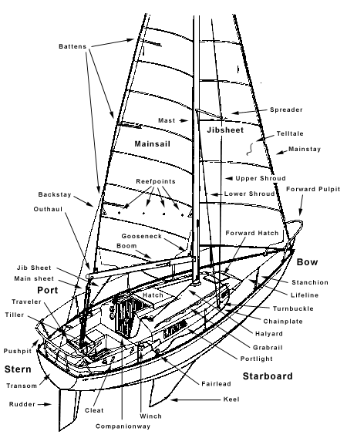

Rigging
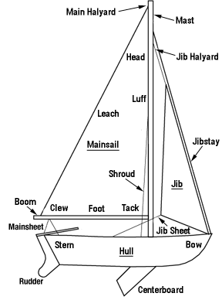
The 3 corners of the mainsail
The 3 sides of a mainsail (or jib)
“bow” rhymes with “cow”

Installing the rudder
- Carry the rudder by its upper stay.
- Insert rudder into its guides on the transom.
- Put tiller through the triangle formed by the mainsheet.
Putting down the centerboard
- Uncleat the centerboard sheet. Its horn cleat is in the middle of the boat. Hold the rope, it will tug toward the bow.
- Feed the rope through its wheel, and the centerboard will rotate down.
- When the centerboard is completely down, cleat the centerboard sheet to clean it up (i.e., get it out of the way) (optional).
Raise the mainsail
- Initial mast feed
  - Main halyard: Uncleat the mainsail halyard. The horn cleat for the mainsail halyard is on the starboard side of the mast.
  - Pin head: The mainsail halyard shackle is pinned with the tack pin along the spine of the gooseneck. Holding the shackle for safekeeping, unpin the shackle, The shackle itself has a pin, which is undone by turning it. Attach the shackle to the head corner of the mainsail and rotate the pin to lock it in.
  - Initial feed: Find the bolt rope on the luff side of the mainsail. Feed the luff side into the groove in the mast. Feed only about a foot of the mainsail into the mast.
- Boom feed
  - Feed: Take the clew corner of the sail and feed it through the boom groove.
  - Pin tack: The tackpin is pinned transversely through the gooseneck. Take the tack pin out of the gooseneck, and place the tack corner into the spine of the gooseneck. Pin the tack corner of the mainsail by transversely feeding it through the gooseneck and tack grommet.
- Outhaul
  - Secure clew: At the end of the boom, there's a short rope called the outhaul, which is tied to a hole. Feed the outhaul through the clew corner grommet, and then again through the outhaul hole. Tug mightily so that the foot of the mainsail is tight. Then pass the outhaul through the nearby outhaul jam cleat, which is about half a foot from the end of the boom. If the outhaul jam cleat doesn’t hold well, then tie around the outhaul rope around itself with two half hitches (in practice, most people tie the two half hitches and don’t bother with the cleat).
- Final mast feed
  - Obstacle check: 3 obstacles to consider:
    - The mainsheet may need to be uncleated (its horn cleat is on the port gunwale).
    - The boom vang may need to be loosened (the rope in the vang runs parallel to it).
    - The cunningham aka the downhaul (the short rope on port side of the mast near the intersection of the boom and mast) may need to be released and taken out of the mainsail.
  - Midway feed: Sitting in front of the mast, and pull the mainsail halyard to raise the mainsail, feeding the bolt rope of the sail parallel to the mast. When the head of the sail reaches the height where the side shrouds meet the mast, pause, and make sure the sail is being raised cleanly. Also, before the sail is raised all the way, make sure that nobody is within reach of the boom, as it can and will swing, especially in high wind.
  - Final feed: Complete the raising. Make sure the halyard is tight as it can be (especially in high wind), by jamming it, pulling the rope, and then taking up the slack. Repeat until no more slack can be taken up.
    - Cleat the mainsail halyard (the horn cleat is on the starboard side of the mast).
    - Tighten the boom vang: pull the end of the rope parallel to the vang, securing the tautness by tugging downwards (i.e., tugging the rope toward the base of the mast).
    - Feed the cunningham through a grommet that is about a foot up from the tack corner, and secure it with a downward motion through the jam cleat on the starboard side of the mast.
Docking (Tying a “Night Knot”)
- Feed a loop of the painter rope (at the bow of the boat) through one of the rings in the dock. With the loop, two half hitches around the rope that leads to the bow.
- Make sure the painter goes through the bow chock (i.e., rope guide).
Furling
- Bring the mainsail down: Uncleat the main halyard. Release the cunningham. Bring the mainsail down by tugging from its tack corner until about a foot remains in the mast. Then cleat the main halyard. Loosen the boom vang so that the boom rests on the boat and place the boom in its groove on the port side of the stern.
- Furl the sail: Find the luff side of the mainsail (where the bolt rope is). Running your fingers along the bolt rope, walk to the stern of the boat and fold the sail in half, like a sheet. From its furthest extension, start rolling the sail up along its bolt rope. Algorithm: make two turns, then shake; repeat until sail is atop the boom. Secure the sail to the boom using the elastic rope along the boom and the hooks along the port side. Keep the weight of the sail on the side away from the hooks.
- Remove the rudder: Remove the rudder and place it inside the boat (a safe place is on the bench on the port side).
- Pull up the centerboard (optional)
- Finish up: Loosen the boom vang. Trim, cleat, and clean up the mainsheet.
Unrigging
Removing the Mainsail
- Steps 1), 3), and 4) <see below for 4)> of furling.
- Take out the foot: Undo the outhaul rope. Remove the tack pin out of the tack corner, re-pin it in place. Feed the foot side of the sail out of the boom groove. When finished, just drop the sail down into the bottom of the boat.
- Take out the luff: Uncleat the main halyard and lower the main sail until the luff is out of the mast groove. Take the shackle off of the head corner, then feed it through the spine of the gooseneck, and pin it in. If it is halyard is too short to reach the gooseneck, feed the cunningham through the pinned shackle and cleat the cunningham. Cleat the main halyard.
- Finish up: Loosen the boom vang. Trim, cleat, and clean up the mainsheet.
Pull up the Centerboard
- Uncleat the centerboard sheet (if necessary).
- Pull the rope toward the stern, and the centerboard will rotate up.
- When the centerboard is completely up, cleat the centerboard sheet.
- Clean up the centerboard sheet by making loops with it and placing the loops between the centerboard and the tense centerboard sheet.
Finishing Up
- Return sail (if necessary), rudder (if necessary), and life jackets.

